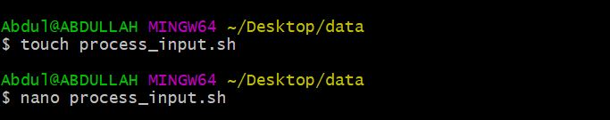

* **Before changes:**

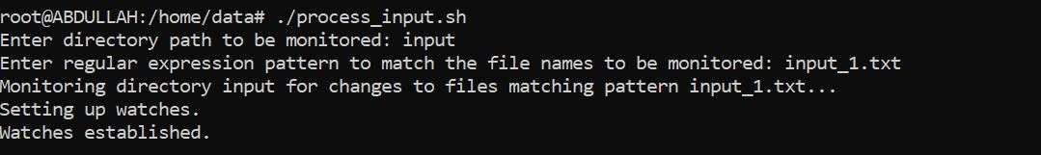

* **After Changes:**
* **New file creation:**

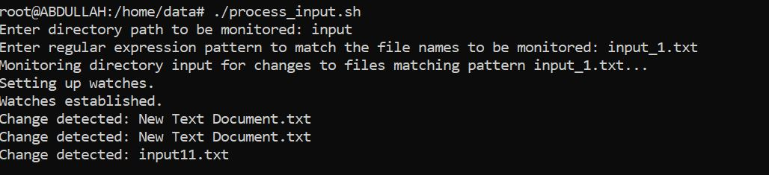

* **Changes inside a file:**

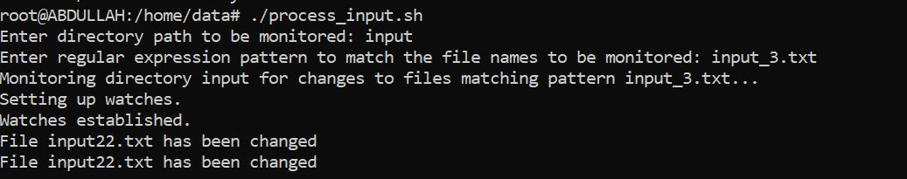

* **process_input.sh Code:**

#!/bin/bash

# Get input from user

read -p "Enter directory path to be monitored: " monitor_dir

read -p "Enter regular expression pattern to match the file names to be monitored: " pattern

# Validate the pattern

if ! [[ "$pattern" =~ ^(input|log)_[1-9]|[1][0]|\.txt$ ]]; then

echo "Invalid pattern"

exit 1

fi

# Check if monitor directory exists and is readable

if [ ! -d "$monitor_dir" ] || [ ! -r "$monitor_dir" ]; then

echo "Monitor directory does not exist or is not readable"

exit 1

fi

# Create backup directory if it does not exist

backup_dir="backup_$(date +%Y-%m-%d_%H-%M-%S)"

if [ -d "$backup_dir" ]; then

read -p "Backup directory already exists. Overwrite (y/n)? " overwrite

if [ "$overwrite" == "n" ]; then

backup_dir="$backup_dir-$(date +%N)"

fi

fi

mkdir -p "$backup_dir"

# Define function to be called on file change

on_change() {

local changed_file="$1"

echo "Change detected: $changed_file"

# Check if file matches pattern

if [[ "$changed_file" =~ $pattern ]]; then

echo "File $changed_file matches pattern"

# Check if file contains specific string

if grep -q "specific string" "$changed_file"; then

echo "File $changed_file contains specific string"

# Extract specific values from file

specific_values=$(awk '/specific string/ {print $1,$2}' "$changed_file")

echo "Specific values: $specific_values"

# Create backup of file

cp "$changed_file" "$backup_dir/"

# Modify file contents

sed -i 's/specific string/new value/g' "$changed_file"

# Check number of lines in file

num_lines=$(wc -l < "$changed_file")

if [ "$num_lines" -gt 10 ]; then

# Extract first and last 5 lines to separate file

head -5 "$changed_file" > /home/data/first_5_lines.txt

tail -5 "$changed_file" > /home/data/last_5_lines.txt

fi

# Compress backup directory with timestamp

timestamp=$(date +%Y-%m-%d_%H-%M-%S)

tar -czf "$backup_dir-$timestamp.tar.gz" "$backup_dir"

fi

fi

}

# Monitor directory for changes

echo "Monitoring directory $monitor_dir for changes to files matching pattern $pattern..."

inotifywait -m -e modify,create,delete --format '%f' "$monitor_dir" |

while read changed_file; do

on_change "$changed_file"

done

# Exit script

exit 0

* **Bash Script to run:**

./process_input.sh